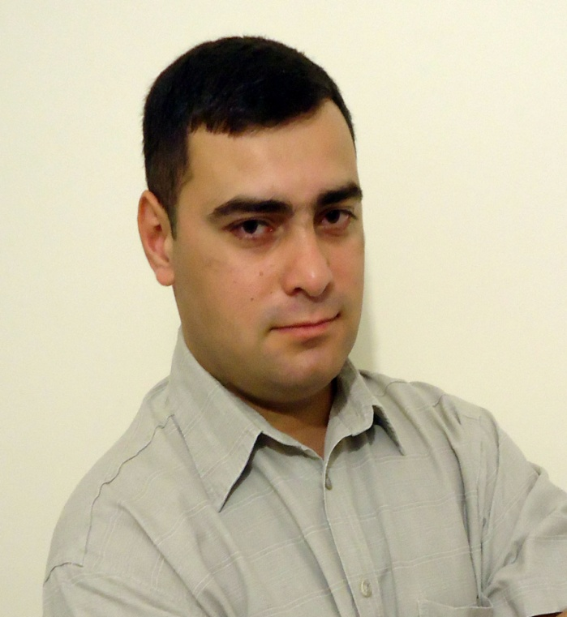
Curriculum Vitae

Name: Shalva
Surname: Tchkadua
Date of Birth: 28.09.1980
Marital Status: Married, three children.

Address: #13, Davit Rectori str., I lane, Telavi, Georgia
Tel.: mob. +995599323810
E-mail: shalvatch@yahoo.com

Education:
2011 - 2012 Beneficiary of Erasmus Mundus ECW Post-Doctoral Program. (University of Sapienza, Rome, Italy)
2009 - 2010 Beneficiary of Erasmus Mundus ECW PhD Program. (University of Macedonia, ATEI, Thessaloniki, Greece)
2007 - 2010 - awarded the Academic Degree of Doctor of History, Iakob Gogebashvili Telavi State University (Research topic: Georgian-Greek Relations at the end of the 20th century and the beginning of the 21st century).
2006 - Master Studies, Iakob Gogebashvili Telavi State University (International Relations and History of Diplomacy).
2004 - Bachelor Studies, Iakob Gogebashvili Telavi State University (International Relations and History of Diplomacy).

Conferences:
2014 - III International symposium “World War I and the Caucasia” (presenter), Iakob Gogebashvili Telavi State University (paper: Georgia and the western countries - “political processes and parallels”).
2009 - International Conference “Religions and Politics in Europe’s Orients” Presentation Topic “Georgians on the bounds of two Empires: Question of Mesxetians”, Thesaloniki, Greece 2009.
2009 - International Conference “Europe, Nations and Borders” presentation topic “Formation of the Political Map of Georgia”, Sofia, Bulgaria.

Publications/Scientific Works/Readers:
2014 - Reader - “Stages of development of the European Union”.
2012 - “The Relations among England, Italy and Georgia in 1918-1921”, Scientific News, number 2, Ganja State University, Azerbaijan.
2011 - “The question of Batumi for Georgia and The Entente Countries in 1918-1921”, International Scientific Journal “Inteleqti” 3 (41), Tbilisi.
2011 - “Short overview of the evolution of Modern Greek state”, Khazar Journal of Humanities and Social Sciences, volume 14, number 4, Khazar
2011 - monograph “The relations between Georgia and Hellenic Republic in 1990-2010”, Publishing House “Sveti”, Tbilisi.
2010 - PhD thesis “The political, economic and cultural relations at the end of the 20th Century and the beginning of the 21st century”.
2010 - “Formation of the political map of Georgia in the 1920-1939: causes and results”, Studia Balcanica 28, Scientific Academy of Bulgaria, Sofia, Bulgaria.
2010 - “The process of establishment of diplomatic relations between Greece and Georgia in the 20th century”, Scientific News 2010/2, Ganja State University.
2009 - ”Political relations between Georgia and Hellenic Republic at the end of the 20th Century and the beginning of the 21st century”, ATEI of Thessaloniki, submitted in partial fulfillment of the requirements for the PHD degree of Humanities, Thessaloniki, Greece.
2009 - “Role of religion in Georgia in XVII-XIX Centuries”. International Relations Society, Intercultural Communications No 10 2009. Tbilisi
2009 - “Collaboration between Georgia and Greece in the sphere of education”. “Ganatleba” No 1, 2009. Tbilisi-Sokhumi.
2009 - “Religious relation between Georgia and Greece (XIX-XX centuries). International scientific journal “Inteleqti” No 2 (34). Tbilisi.
2008 - “Relations between Georgia and Greece in the military sphere”. The Collection of the Scientific Works of I. Gogebashvili Telavi State University No2 (24). Telavi.
2008 - “The Greek policy towards Georgia”. The Collection of the Scientific Works of I. Gogebashvili Telavi State University No2 (24). Telavi.

Trainings:
2017 (December 7-9) – participant of training “Quanitative Research Methods in Social Sciences” organized by University of North Texas and Know How Training Center at Telavi State University, Telavi, Georgia.
2016 (July 27) – participant of training “21st century Teaching Methods” organized by University of North Texas and Know How Training Center at Telavi State University, Telavi, Georgia.
2013 - Democracy School of the Netherlands Institute for Multiparty Democracy
2012 - participant of training “Basics of local government, presentation skills and project management” organized by GIPA and Open Society Georgia Foundation, Telavi, Georgia.

Working Experience:
2014 - till now - Associate Professor in Political Sciences, Faculty of Social sciences, Business and Law, Iakob Gogebashvili Telavi State University.
2013- till now Head of Quality Assurance Service of Iakob Gogebashvili Telavi State University
2012 - 2014 - visiting lecturer of History, Faculty of Humanities, Iakob Gogebashvili Telavi State University.
2011-2012 - Specialist at the Faculty of Social sciences, Business and Law at Iakob Gogebashvili Telavi State University.
2006– 2011 - Embassy of Greece in Georgia, Defence Attaché Office
2005-2006 - Assistant of administrator at National Education Center of Telavi
2005-2006 - Teacher of the History of Neighbour Countries at Erekle II Gymnasium of Telavi
2004 – 2007 - Teacher of the Greek Language at Greek Society “ELLADA” of Kakheti Region.

Other activities:
Since 2014 - Supervisor of students’ conference papers
Since 2013 - Supervisor of bachelor theses

Language Skills: Georgian (native), English, Greek (certificate), Italian (certificate).

Computer Skills: Word, Excel, PowerPoint, Internet.

Other Skills: Driving license - B and C category.

